DBMS - 1

LAB REPORT 2

**SUBMITTED BY:**

**SHAHZANEER AHMED**

**REGISTRATION**

**NUMBER**

**:**

**SP21**

**-**

**BCS**

**-**

**087**

**SUBMITTED TO**

**:**

**Dr. Basit Raza**

**DATE**

**OF**

**SUBMISSION:**

**November 11, 2022**



Q1: Write SQL statements for the following information needs:

* + 1. **Find the highest, lowest, sum, and average salary of all employees. Label the columns as Maximum, Minimum, Sum, and Average, respectively. Round your results to the nearest whole number.**





* + 1. **Write a query to display the number of people with the same job.**



* + 1. **Determine the number of managers without listing them. Label the column as Number of Managers.**





* + 1. **Find the difference between the highest and lowest salaries. Label the column DIFFERENCE.**





* + 1. **Create a report to display the manager number and the salary of the lowest-paid employee for that manager. Exclude anyone whose manager is not known. Exclude any groups where the minimum salary is $6,000 or less. Sort the output in descending order of salary.**

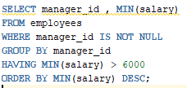

* + 1. **Create a query to display the job, the salary for that job based on department number, and the total salary for that job, for departments 20, 50, 80, and 90, giving each column an appropriate heading**

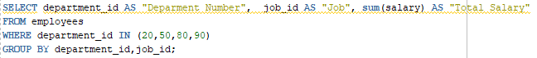

**Q2: Write SQL statements for the following information needs:**

1. **The HR department needs a report to display the employee number, last name, salary, and salary increased by 15.5% (expressed as a whole number) for each employee. Label the column New Salary**



1. **2- Write a query that displays the last name (with the first letter in uppercase and all the other letters in lowercase) and the length of the last name for all employees whose name starts with the letters “J”, “A”, or “M”. Give each column an appropriate label. Sort the results by the employees ‘last names. Rewrite the query so that the user is prompted to enter a letter that the last name starts with. For example, if the user enters ―H‖ (capitalized) when prompted for a letter, then the output should show all employees whose last name starts with the letter ―H.**

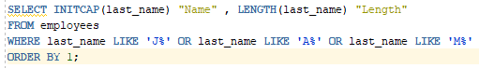

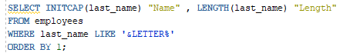

1. **3- The HR department wants to find the duration of employment for each employee. For each employee, display the last name and calculate the number of months between today and the date on which the employee was hired. Label the column as MONTHS_WORKED. Order your results by the number of months employed. Round the number of months up to the closest whole number.**



1. **4- Create a query that displays the employee’s last names and commission amounts. If an employee does not earn commission, show ―No Commission. Label the column COMM**



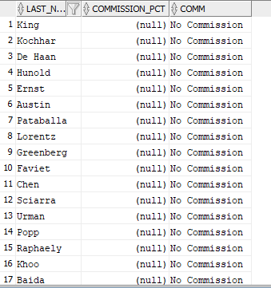

1. **5- The HR department needs a list of countries that have no departments located in them. Display the country ID and the name of the countries. Use the set operators to create this report.**

1. **The HR department needs a report with the following specifications:**

* **Last name and department ID of all employees from the EMPLOYEES table, regardless of whether or not they belong to a department**
* **Department ID and department name of all departments from the DEPARTMENTS table, regardless of whether or not they have employees working in them.**



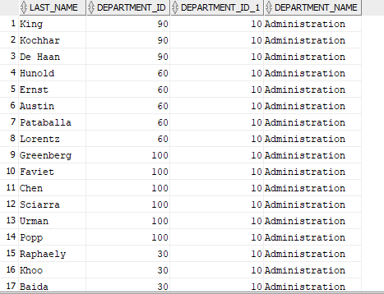

**Q3: Write SQL statements for the following information needs:**

1. **Write a query for the HR department to produce the addresses of all the departments. Use the LOCATIONS and COUNTRIES tables. Show the location ID, street address, city, state or province, and country in the output. Use a NATURAL JOIN to produce the results.**



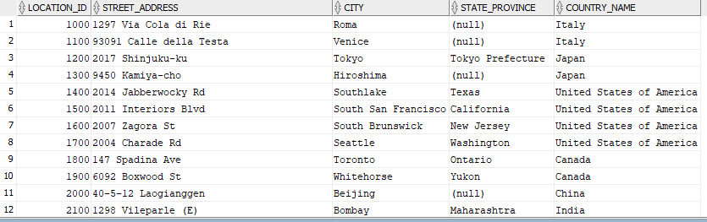

1. **The HR department needs a report of all employees. Write a query to display the last name, department number, and department name for all the employees.**



1. **The HR department needs a report of employees in Toronto. Display the last name, job, department number, and the department name for all employees who work in Toronto.**



